HAMMERSMITH HEAD
Sunday 23 February 2025 at 11:30am
Rules and Safety Instructions to Competitors

GENERAL
- Hammersmith Head will be rowed under the British Rowing Rules of Racing, the PLA Rowing & Paddling on the Tideway Code of Practice and complying with: British Rowing RowSafe safety code, the PLA 2014 requirements for rowing races on the Tideway and the PLA system of Ebb Tide Flag Warning.
- The Personal Ranking System will be applied to all senior events as outlined in section 3 of the British Rowing Rules of Racing to split the events into up to four categories. The banding parameters applied will be published on the Hammersmith Head website at the time of the draw.
- The order of start, maps, safety instructions and any amendments will posted on the Hammersmith Head website.
- Any change in crew composition must be entered on the BROE2 website or notified to the Entries Secretary via e-mail - hammersmithhead@outlook.com - prior to racing.
- Substitutions must adhere to the BR Rules of Racing and the 125% points limit as set out in the Personal Ranking Handbook. In the event of a substitution which takes a crew above the 125% limit, that crew shall race Time Only for their band but are still eligible for the overall prize.
- On the day of the race, Race Control can be contacted at Chiswick Pier House, tel. 07932 085054
- In previous years, entries have been oversubscribed given the restrictions of Tideway marshalling. To help ensure a more balanced entry this year we will continue with the following principles:
  - 50 % of the entry will be reserved for Senior crews
  - We reserve the right to cancel events that are under subscribed (less than 8 crews)
  - For Junior events each club may be restricted to a maximum of two entries

SAFETY
- Competitors are responsible for their own safety both ashore and afloat, which is of overriding importance at all times.
- When making an entry, club Captains must ensure that that their crews are fully briefed and competent to race in the conditions likely to be experienced on the Tideway. On the day of the event, every individual participant must, with the help where appropriate of a responsible adult, carry out their own personal risk assessment before boating. That risk assessment must include their fitness, health, equipment and technique to determine whether or not they are able to race in the conditions as they find them. THE RACE ORGANISERS ACCEPT NO LIABILITY FOR ACTIONS OF THE CREWS OTHER THAN WHEN DIRECTLY INSTRUCTED BY THE HEAD ORGANISERS AND MARSHALS AND CREWS RACE AT THEIR OWN RISK.
- In accordance with TRRC rules, any crew or club which is involved in a verifiable navigation incident on the Tideway may be excluded from the event. This rule will apply to incidents for the fourteen days prior to and including the day of the event.
- All crews and coxes are assumed to have watched the PLA video “Safely navigating in the upper tidal Thames”. An introduction to steering on the Tideway is available from the TRRC website . The act by your club of putting in an entry will be considered as confirmation that every member of the crew has seen these videos and documents and that these have been read and understood by all steers.
- The River will be closed for this event between Barn Elms and Kew Railway Bridge from 10.30 until 14.30 under PLA NTM U27-24. During that period crews must navigate in accordance with the requirements of these Rules and the arrangements in the Safety and Emergency Plan for marshalling, racing finishing and abandonment. Crews must give consideration to other river users. You do not have automatic right of way or priority.
- Crews must obey all instructions from Officials. Failure to observe this rule may lead to a time penalty or disqualification.
- Mechanical Breakdown/Failure: Should a crew have a mechanical steering failure it is essential that the crew stop racing and notify an official of the problem. Crews must not put themselves or others at risk by trying to finish the race with defective steering.
- If a member of a crew should fall out of their boat it is essential that the crew stop and help. Following crews must take avoiding action.
- First Aid facilities are available at Auriol Kensington RC and Chiswick Pier House. Points for best access by ambulances are also shown on the course safety map.
- Crews are advised to carry a mobile phone. Safety cover will be provided by the event until half an hour after the last crew has completed the course. If a crew has to contact the emergency services, they should dial 999 and ask for the COASTGUARD.
- Crews are advised to take suitable footwear with them in the boat.

BOATING ARRANGEMENTS
- Non-Tideway crews must make prior arrangements direct with their intended host club regarding availability of changing and boating facilities. These can be limited and host clubs may be unable to cater for unexpected visiting crews.

CREW NUMBERS
- Prior to racing all crews must collect their numbers from registration at Auriol Kensington RC. Registration will be open for the collection of numbers from 08.30 on race day. The paper numbers must be pinned on the back of the bowman and the back of the cox so as to be visible at all times when marshalling and racing. Plastic (“Empacher”) Numbers are provided for attachment to the bows of the boat. The adhesive numbers are for the bow of the boat on the saxboard below bow persons seat The bow number should be securely fixed and any numbers lost for whatever reason will mean the forfeit of the £10:00 deposit.
- Competitors who have not paid their Entry Fees will not be issued with their crew numbers and will not be permitted to race.
MARSHALLING
- Crews are strongly advised to leave their boathouses in good time – allow 60 minutes to get to the start from Putney and 40 minutes from Hammersmith to take account of the large number of crews on the river. With up to 350 crews afloat, all are asked to be alert to the needs of other crews at all times.
- Crews must be in their marshalling position by 11.10 (10 minutes before the race start time). Crews not in their marshalling position on time may receive a time penalty.
- Crews will be marshalled in six divisions, each division consisting of around 50-60 crews. (NOTE: division sizes and numbers will not be finalised until after the draw)

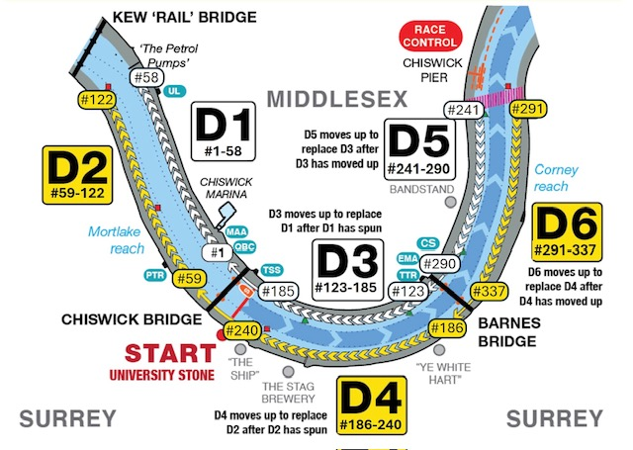

Crews | Division | Description
1 – 58 | Division 1 | Marshalled on Middlesex bank, number 1 nearest Chiswick Bridge; number 58 off ULO
59 - 122 | Division 2 | Marshalled on Surrey bank; number 59 above Putney Town RC; number 122 opposite ULO
123 - 185 | Division 3 | Marshalled on Middlesex between Barnes Bridge and Chiswick Bridge; number 123 nearest Barnes Bridge; number 185 below Chiswick Bridge
186 - 240 | Division 4 | Marshalled on Surrey between Barnes Bridge and Chiswick Bridge; number 186 above Barnes Bridge opposite TTRC; number 240 below Chiswick Bridge opposite TSS
241 - 290 | Division 5 | Marshalled on Middlesex between Barnes Bridge and the Chiswick crossing point, number 241 at the crossing point, number 290 below Barnes Bridge off Emanuel School BC
291 - 337 | Division 6 | Marshalled on Surrey between Barnes Bridge and the Chiswick crossing point, number 291 at the crossing point, number 337 below Barnes Bridge opposite Emanuel School BC
- Late arriving crews may be held downstream of Chiswick Bridge and will be started at the end of the next appropriate division.
- Crews should take care when using the Middlesex arch of Barnes Bridge, due to the newly constructed footbridge that passes under the arch close to the Middlesex bank.
- Crews boating from clubs within the marshalling area may not boat late in order to join their division as it moves up.
- While marshalling, crews must keep as close to the bank as possible. Boats must maintain their position against the tide and neither allow themselves to become bunched together or allow gaps of more than one length of clear water to open up between them. No crew is to paddle at race or firm pressure in the marshalling area.
START
- This will be on time and without reference to absentees. Crews arriving late in the marshalling area may be started at the end of the race.
- On being told to do so by the marshals you are to turn and proceed downstream in numerical order. Crews should pass through the centre arch of Chiswick Bridge to reach the starter below Chiswick Bridge who will start you by saying “Number …. Go!” Timing will begin at Boat Race finish post and not when the starter says, “Go”. All crews have a flying start. Boats should be closed up until there are three lengths of clear water between them at the start. On no account are boats to be overlapping when crossing the start line.

RACING (the following replace rules 7-5-2, 7-5-3, 7-5-5 and 7-5-7 of the British Rowing Rules of Racing)
- Race navigation: Racing crews must remain in the fairway and may not pass outside of the red and green navigation buoys; they must use the centre arch of Barnes Bridge, and the centre arch of Hammersmith Bridge.
- Boats being overtaken MUST give way, and boats overtaking MUST do so safely. All crews have a responsibility to avoid collision. An overtaking crew must make their intentions clear: they may overtake on either side but are advised that keeping the overtaken crew to starboard is likely to be faster.
- Marshals/observers may warn crews for their steering and crews risk a time penalty or disqualification if they interfere with or foul another crew.

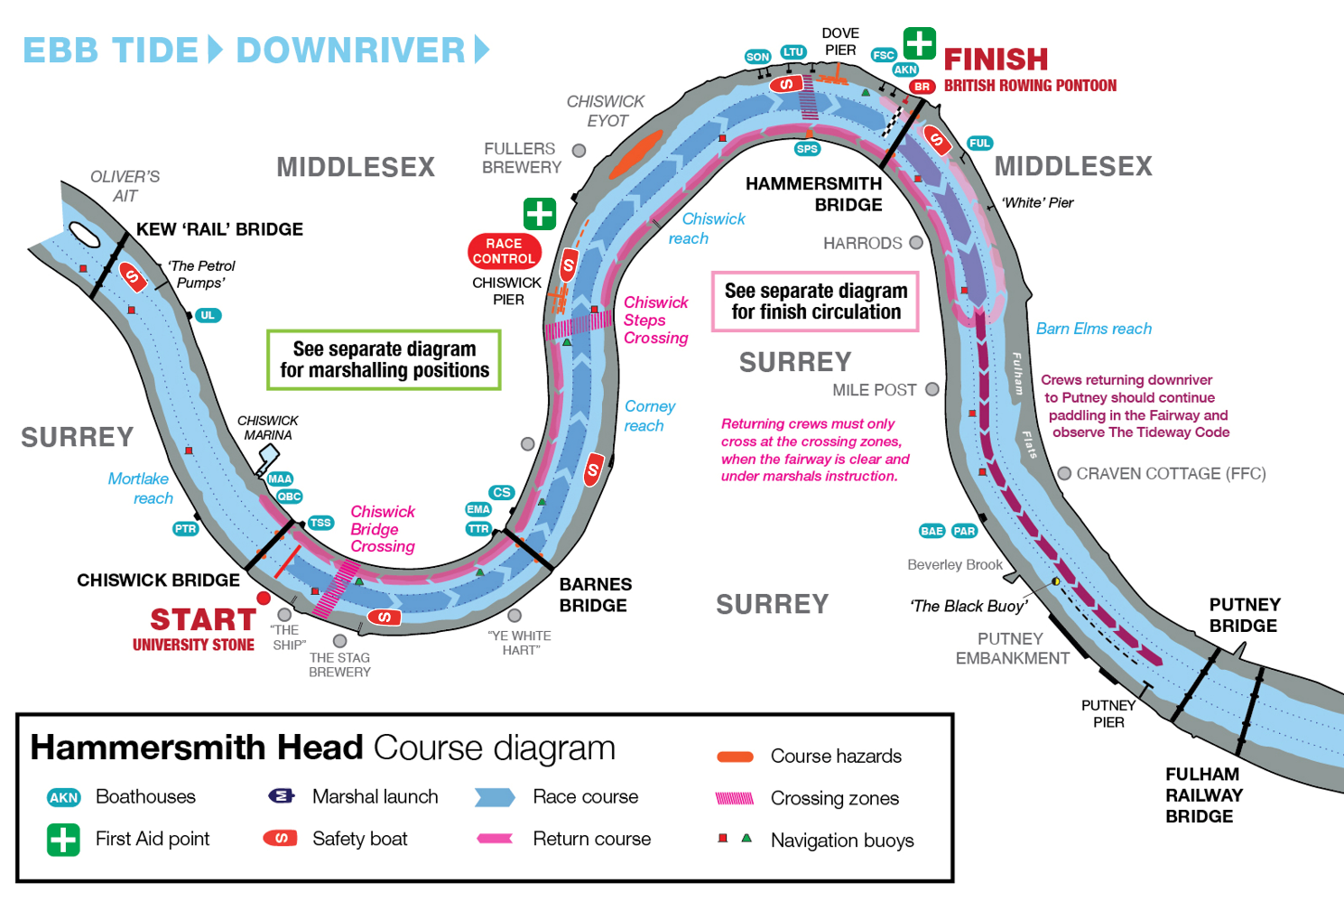
CYCLING
- Attempting to follow a racing crew using a bicycle on the towpath is not recommended, but if attempted the cyclist must be alert to and give way to pedestrians. Failure to do so may result in the crew being followed receiving a penalty or disqualification.

FINISH & RETURNING
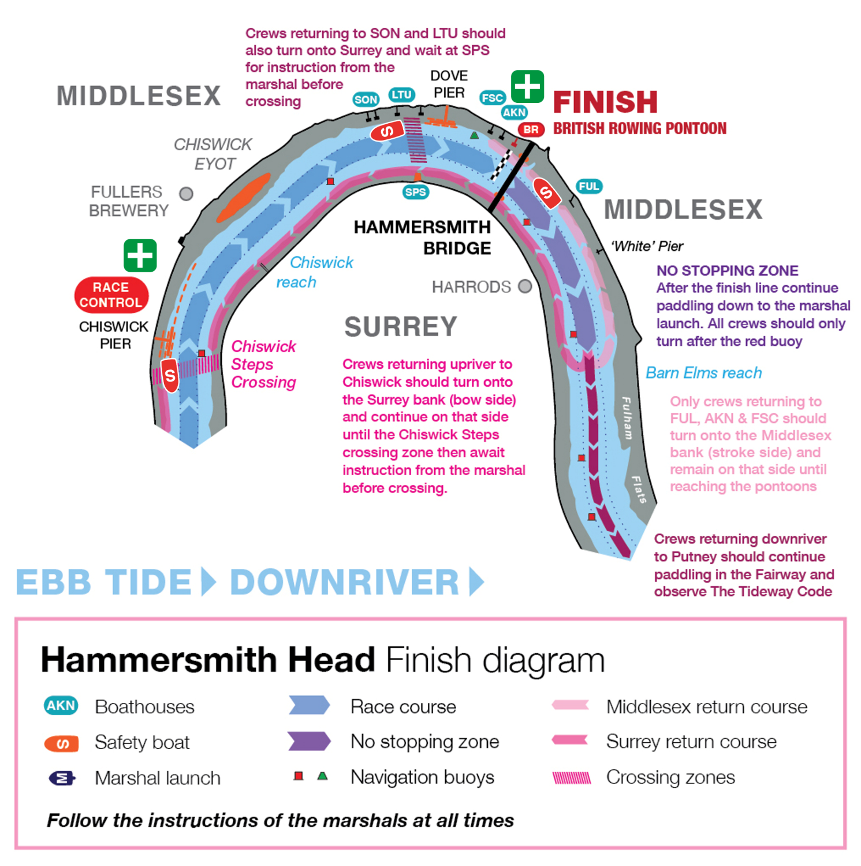
- After passing the finish line just before Hammersmith Bridge crews should continue without overtaking, until the second PLA red buoy (this is the Tea Rose buoy after Harrods Wharf) before turning or proceeding downstream. Please beware of finishing crews. Crews should keep a sharp look out particularly after the race when you are tired.
- Crews returning to the AKRC, Fulham Reach and Furnivall boathouses at Hammersmith should turn to the Middlesex bank. Bear in mind that crews on the fairway have right of way.
- Crews returning to the Hammersmith boathouses above Dove Pier (Latymer Upper and Sons of the Thames) should turn to the Surrey bank. Stay close to the bank and do not attempt to cross the course until above Dove Pier and instructed to do so by a race official.
- Crews returning to boathouses further upriver should remain on the Surrey bank and either cross under the direction of a marshal at the Chiswick Steps crossing (for boathouses on the Middx bank) OR, for Putney Town boathouse and whilst the race is still underway, remain on the Surrey bank all the way to PTRC.
- Returning crews must not pass any marshalling crews that are still waiting to race.
- The river closure ends as the last crew rows down the course. After this time normal Tideway navigation rules apply.
PROTESTS
- Any appeal or complaint must be made to the Race Committee Chair at Chiswick Pier House. Protests may be made up to one hour after the last crew has finished. No appeal or complaint will be considered after the results have been announced.
- No crew will be given a time faster than that which it actually recorded for the race.
- In any dispute the decision of the Race Committee shall be final and without appeal.
REFUNDS
- If the event is cancelled more than 72 hours before the start time, we will endeavour to refund the maximum amount possible subject to unrecoverable costs; if the event is cancelled more than 12 hours before the start time (but less than 72 hours before), we will aim to refund up to £50 for eights/octos and up to £30 for fours / quads; if the event is cancelled less than 12 hours before the start time, we will aim to refund up to £30 for eights/octos and up to £20 for fours / quads.

